Face Mask Removal Using Cycle GAN(Generative Adversarial Networks)


GAGAN DAYANANDA

Applied Research Project submitted for the degree of
M.Sc.Artificial Intelligence
At Dublin Business School

Supervisor: Assem Alsawy Abdel-Hak

September 2025

DECLARATION

‘I declare that this Applied Research Project that I have submitted to Dublin Business School for the award of M.Sc. Artificial Intelligence is the result of my own investigations, except otherwise stated, where it is clearly achknowledged by references. Furthermore, this work has not been submitted for any other degree.’

Signed: Gagan Dayananda
Student Number: 20041922
Date:

ACKNOWLEDGEMENT

I would like to extend my heartfelt thanks to Professor Assem Alsawy Abdel-Hak for the priceless guidance and supervision he provided throughout the completion of my master’s thesis. His guidance, support, and feedback played an important role in shaping this research and helped me overcome the challenges I faced during the project. I am deeply thankful to my family and friends for their support and motivation through my studies.

TABLE OF CONTENTS

ABSTRACT 3
CHAPTER I.INTRODUCTION 4
I.I The Rise Of Masked Faces In Recent Times 4
I.II The Challenges of Occluded Faces 4
I.III Objectives Of The Face Mask Removal Model 5
I.IV Guiding Questions to the Study 5
I.V Limits And Restrictions 6
CHAPTER II. LITERATURE REVIEW 7
II.I Generative Adversarial Networks And Their Evolution 7
II.II Cycle GAN and Unpaired Image-to-Image Translation 8
II.III Structural Similarity (SSIM) and its application in GANS 9
The significance of SSIM to generative models 9
II.IV Ethical Considerations Of Face Reconstructions 9
II.V Face Reconstruction and Mask Removal Applications 10
CHAPTER III. METHODOLOGY 12
III.I Description of the dataset 12
III.II Preprocessing 14
Steps in preprocessing: 14
1. Load the image 14
2. Resizing the image 14
3. Normalization 14
4. Shuffling 14
5. Batching 14
6. Prefetching 14
III.III Model Architecture 15
Generator Architecture 15
Key characteristics: 15
Discriminator Architecture 17
Key characteristics: 17
III.IV Reason for chosing U-Net generators and PatchGAN discriminator 18
III.V Implementation of CycleGAN Model And The Process Of Generating Images 18
Structure and Components of a Model 18
1. Discriminator Loss 19
2. Generator Loss 19
3. Cycle Consistency Loss 19
III.VI Model Compilation and Hyperparameter Selection 19
III.VII Training Process and the Adversarial Dynamics 20
Discriminator Update: 20
Generator Update : 20
Facial Tracking using Callback 20
CHAPTER IV. EVALUATION 21
IV.I Data Split 21
IV.II Train Monitoring 21
IV.III Discriminator Accuracy 22
IV.IV Structural Similarity Index (SSIM) 22
Implimentation Details: 23
Scores Interpretation 24
IV.V Ethical Use of Facial Data in Mask Removal 24
Informed Consent 25
Access Control and Transparency 25
CHAPTER V. RESULTS & DISCUSSIONS 26
V.I Generator Loss(Masked Domain) 27
V.II Generator Loss(Un-Masked Domain) 29
V.III Key Findings of the Generator Losses 31
V.IV Discriminator Accuracy 31
V.V SSIM ACCURACY 32
V.VI Visual Performance 33
V.VII Limitations of the Model 36
V.VIII Future Works 37
CHAPTER V. CONCLUSION 39
References 41

ABSTRACT

The broad adoption of face masks in the COVID-19 pandemic has created serious issues that face recognition and computer vision systems face especially when certain facial features that they rely on are covered. In this study, a deep learning based method has been introduced to unmask the unmasked faces based on masked data (generated by Cycle-Consistent Generative Adversarial Networks, or CycleGAN). The task is to produce realistic and identity-consistent face images without the need to produce paired training data. A pairing of approximately 10,000 images was created by combining masked face images scraped from Google with unmasked face images obtained by Jessica Li using the CelebFaces dataset. The model was developed and trained with the use of TensorFlow and the focus was put on the unpaired image-to-image translation. The preprocessing techniques was used to resize, normalize, and augment the images to make the learning robust.The model performance was compared in terms of structural similarity index (SSIM) and qualitative visual inspection.The findings suggest that the CycleGAN can effectively remove masking and generate convincing facial structures, but still limits in maintaining fine, identity-related detail under occlusion.This paper is a contribution to the image synthesis, restoration and unpaired learning community. This paper also demonstrates how CycleGANs can be used to remove face masks. Ethical considerations, especially in the aspect of privacy and possible misuse of a generative model, are also reflected in the study. Future directions include the study of identity preserving GANs, and more resolution output as a way to improve the quality of reconstruction.

CHAPTER I.INTRODUCTION

I.I The Rise Of Masked Faces In Recent Times

Face masks and their role in everyday life did not appear until recent years because of the worldwide health issues such as the corona virus epidemic. Although necessary to increase the level of public safety, this transition has generated new problems in areas where facial visibility is a core element, including biometric verification systems, surveillance technology, tracking the expression of emotions, and human-computer interaction. Due to this outcome, masking of parts of the facial area is becoming an issue of concern, as there is a rising interest in technology that can be used to reconstruct such areas to restore the value of the data in digital apps.

The task of determining masked faces is a complicated issue, as masked regions are unseen and must be inferred and generated by the model. It is not only an image synthesis task but also needs a high-level concept of facial structure, identity, and contextual information. GANs have proved to be effective in such generative tasks as they can generate visual realistic images. Specifically, the study uses a modification of GANs known as CycleGAN to unmask faces in photographs without the need to have paired data.

CycleGAN operates in an unpaired learning framework, unlike supervised approaches, which is essential in contexts in which datasets do not consist of one-to-one mappings between masked and unmasked images. It can help it fill in data in missing regions, but without violating the identity of individuals, by learning mappings between the two domains. The capability does not only enhance performance of face recognition and verification systems but also applications in security, healthcare diagnostics and human computer interaction. In addition, the solution will help improve fairness and robustness of AI systems through reliable outputs when facing partial occlusions.

I.II The Challenges of Occluded Faces

The vast majority of classical computer vision models make the assumption that facial data is available completely and obstruction-free. But due to masks covering some major features like nose, mouth and jawline, such systems would either fail or give unreliable results. Whereas classical inpainting techniques are aimed at filling in missing regions, they do not usually have semantic knowledge and cannot be used in ways where preservation of identity or facial symmetry is required.

The main difficulty is how to train the model to produce reasonable reconstructions of masked facial features without access to ground-truth pairs of masked and unmasked images. Further, reconstructed outputs need to be visually consistent, identity-preserving, and artefact-free, which is hard to accomplish using typical image completion methods. This study examines how CycleGAN can tackle this challenge with an unpaired masked and unmasked face dataset.

Another challenge is introduced by the fact that the types of masks, shapes, and colors are more diverse, the more variability in the types of occlusions a model should learn how to deal with. Additionally, variations in illumination, body stances and skin color compound the reconstruction problem further. Ethical issues are being raised beyond the technical obstacles in the possible misuse which highlights the necessity of such systems to be deployed and designed responsibly. In spite of these challenges, new breakthroughs in generative modeling hold potential avenues to more trustworthy and identity-respectful reconstructions. By solving these problems, the proposed research attempts to make a contribution to providing strong facial analysis in the world where the partial occlusion has become commonplace.

I.III Objectives Of The Face Mask Removal Model

This project will intend to build a deep learning model capable of successful reconstruction of unmasked images of faces when using masked information. The study aims to avoid the requirement of direct, paired dataset, which is not easily available in the real world by harnessing the ability of unpaired image-to-image translation proposed in CycleGAN.

The major objectives are:

- Training and developing a Cycle GAN model and train it to learn the mapping of masked and unmasked face domains.

- Preprocessing and preparing a dataset that allows unpaired training, using not only publicly available images but also using existing facial datasets.

- Assessing quality and structural accuracy of the reconstructed images through visual assessment and quantitative parameters like Discriminator accuracy and SSIM(Structural Similarity Index Measure).

- Addressing both ethical and practical consequences of reconstructing human facial features by using artificial intelligence.

I.IV Guiding Questions to the Study

In order to establish the direction of the research, and measure its success, the following key research questions have been determined:

- Is it possible to actually train CycleGAN to un-mask realistic facial images using unpaired data of masked faces and unmasked faces?

- How close and structurally matching are the outputs made on the facial appearances visually and based on image similarity measures?

- What are the ethical dangers or issues surrounding automated face mask removal, especially with regard to privacy, bias, and possible abuse?

These questions assist in bringing the methodology, evaluation process and discussion into the context of the essence of the project.

I.V Limits And Restrictions

Although this study aims at realistic removal of face masks, the limitations and scope restrictions apply to the goal set.

- The project does not deal with video or real-time removal of mask but only with static images.

- The dataset is composed of Google (masked faces) and CelebFaces dataset (unmasked faces) scraped images. These were not identity-paired, with the masked and unmasked images being of different individuals.

- Frontal or near-frontal facial images only are taken into consideration. In this version of the model, extreme poses, occlusions, or side profiles are not supported.

- And identity preservation is not clearly enforced through a method and procedure such as facial embedding or identity verification software.

- The assessment uses mostly visual analysis with support of structural similarity measurements (e.g. SSIM) without actual user studies or utilization of face recognition models to test identity match.

- Ethical risks are tackled but not technically addressed in the model (e.g. there is no watermarking, detection, or misuse limitation).

- Such limitations assist in determining a real and narrowed down range of issues as well as pinpointing potential areas of growth in the future.

CHAPTER II. LITERATURE REVIEW

II.I Generative Adversarial Networks And Their Evolution

Generative Adversarial Networks (GANs), a system proposed by Goodfellow et al. (2014) have revolutionized the field of generative modelling in computer vision to make impacts in tasks like image synthesis, translation and restoration. Here the generator is used to create synthetic data that is meant to match the true distribution whereas the discriminator is used to differentiate the real and generated samples. Generator uses this adversarial training to learn elaborate data distributions so that outputs are highly perceptually realistic.
Since the GANs were introduced, a variety of variants have been created to solve issues related to performance instability, mode collapse, and constraints on the content of the generated material. Deep Convolutional GAN (DCGAN) uses convolutional layers introduced by Radford et al. (2015) in order to achieve better quality and stability of images during training. Mirza and Osindero (2014) generalized the framework by adding Conditional GANs (cGANs), so that the process of generation became conditioned on additional knowledge, e.g., in terms of class labels.

To further stabilise the GAN training process, Arjovsky et al. (2017) proposed Wasserstein GAN (WGAN), which incorporates Earth Mover distance to enhance the gradient flow, whereas Gulrajani et al. (2017) further improved the above scheme by including a gradient penalty (WGAN-GP) to avoid the problem of convergence.
GANs have proven to be powerful in facial image processing, where its tasks are mostly in face generation, editing, aging and inpainting. Choi et al. (2018) in their work StarGAN allow the editing of faces across a multitude of domains with a single cohesive model and Karras et al. (2019) on their part developed StyleGAN which can synthesise incredibly detailed and photorealistic facial imagery. These developments take advantage of semantic knowledge of face structure, and use loss functions like the perceptual loss and identity loss to guarantee both realism and identity retention in reconstructed faces.

A significant contribution was made by Zhu et al. (2017) who introduced CycleGAN that can be used in tasks where images and machine translation are not in pairs. The cycle consistency loss used by CycleGAN makes it possible to learn mappings between two domains without access to paired training data (as would be the case in a task such as face mask removal), a desired property. The two way mapping makes transformed images have the same semantic structure as well as the identity of the original subject which is important in tasks that use human faces.
In summary, recent developments in GAN architecture make it one of the building blocks of higher-level face reconstruction problems. They can be easily adapted, and together with domain-specific adjustments and training datasets can be as well suited to the creation of realistic and robust face mask removal systems.

In summary, recent developments in GAN architecture make it one of the building blocks of higher-level face reconstruction problems. They can be easily adapted, and together with domain-specific adjustments and training datasets can be as well suited to the creation of realistic and robust face mask removal systems.

II.II Cycle GAN and Unpaired Image-to-Image Translation

Cycle-Consistent Adversarial Networks (CycleGAN) proposed by Zhu et al. (2017) have been hailed as a breakthrough in image-to-image translation, specifically, in the domain where paired datasets are not accessible. In contrast to existing supervised models like Pix2Pix that are designed to learn one-to-one mappings between a source and a target image, CycleGAN allows learning mappings between two visual spaces that are defined by unpaired image samples. This is accomplished by a special limitation called cycle consistency, which guarantees that an image changed between one domain and another and returned back at the origin ought to be indistinguishable to the orginal input.

Such architectural design is particularly useful regarding face mask removal. Supervised learning techniques cannot be practically used in real-world datasets since aligned pairs of masked and unmasked face images of the same individuals are generally not available. To overcome this drawback, CycleGAN learns to operate directly on independent masks and non-masked images and it can therefore hallucinate the occluded parts of the face (like nose, mouth, lower face) with significant semantic accuracy.

By extending the original framework, recent work has seen the addition of attention mechanisms, identity preservation loss, and perceptual loss with the aim of better capturing facial detail and retaining distinguishing features. As an example, attention-based CycleGANs showed potential in directing the output of the generator on the region covered by the mask, averting irrelevant changes on the other areas of the face. Similarly, the application of residual connections and multi-scale discriminators has been used to achieve top-quality texture and image sharpness, especially in high-resolution domains.
Nevertheless, there are still some difficulties. The model can produce a blurred or otherwise anatomically inaccurate facial features under heavy occlusion or strange lighting conditions. In addition, maintenance of finer details of identity is a topic of future study, including asymmetry of the face or texture. Such drawbacks explain the necessity of better loss functions and larger and varied training data to achieve generalization.

Overall, CycleGAN has established itself as one of the cornerstone methods in unpaired image-to-image translation and became an effective tool to solve the problem of face mask removal. Its capacity to execute domain translation in absence of explicit pairings proved to be an effective method of applicative use in which the paired information is little, showing the transforming promise of adversarial learning in the practical facial reconstruction problems.

II.III Structural Similarity (SSIM) and its application in GANS

The SSIM was proposed, as a perceptual alternative to pixel-wise error (e.g., MSE/PSNR). Rather than comparing the pixels individually, SSIM local structure considering small windows between the two images and breaks up the quality into the three terms of luminance, contrast, and structure and later they are combined. The essence of this is straightforward and anthropomorphic, i.e., the layout of an image is maintained, people are likely to reason it to be at the same level when the absolute values of pixels change. Wang et al. (2004) formalized this by demonstrating structural similarity correlates better with human judgments than traditional measures of error visibility.A variant, called Multi‑Scale SSIM (MS‑SSIM), applied this to image scales to make it more robust (e.g. to changes in resolution and viewing distance). MS-SSIM estimates SSIM on successively downsampled forms of the images and adds the scores, which usually results in better correspondence with human perception of natural imagery.

The significance of SSIM to generative models
In generative vision activities (reconstruction, translation, synthesis), we are concerned not only about error, but about what observers perceive. To a large extent, as deep learning has matured, it has become evident that perceptually informed training objectives can produce images that people prefer- in some cases even at a reduced PSNR. As one example, Zhao et al. (2017) subsequentially investigated SSIM/MS‑SSIM (and its combinations with L1) as loss functions in image restoration networks, achieving perceptual improvement compared to L2. The derivatives that they computed in their work also resulted in SSIM/MS-SSIM being practical in backpropagation.

II.IV Ethical Considerations Of Face Reconstructions

The use of generative models with the purpose of reconstructing facial images is a problem that raises some important ethical concerns that have been commonly addressed in recent literature. Rossler et al. (2019) point out that along with the positive usage, such as repairs to damaged pictures, or helping forensic analysis, the development of deep generative methods facilitates negative applications such as deepfakes and spoofing identities. Such risks are increased in models being able to reconstruct occluded or masked faces as they may override privacy protections, disclosing personally identifiable information without consent.

The issue of privacy is especially severe in the situations when individuals have intentionally covered some of their face, e.g. during the situations of public health concerns or during political protests. Brundage et al. (2018) state that this type of reconstruction can violate the individual right to privacy, managing their own biometric identity, and biometric data is considered sensitive personal data in numerous jurisdictions, including the General Data Protection Regulation (GDPR) in the European Union. On the same note, Jain et al. (2016) warn that the application of biometric reconstruction technologies may make people lose faith in the regime of data protection in case they are implemented without being tightly controlled and regulated by ethical considerations.

In a social context, Harvey and LaPlace (2021) point to the possibility of bias exaggeration in reconstructed facial images. In cases where the training data supplied to generative models may be skewed by the representation of specific demographics, the regenerated results can unintentionally discriminate or even favour given groups. Such an issue is consistent with the results of Buolamwini and Gebru (2018) who show that facial analysis models trained with bias on unbalanced datasets tend to exhibit low accuracy on underrepresented groups, leading to concerns on whether such AI implementation is fair and equitable.
The issue of informed consent has also been covered by scholars. Tonge et al. (2021) state that any face reconstruction system should be complemented by clear guidance on how data will be used and the subjects whose facial data will be used to train or test the system should be made aware of the potential risks. It is believed that such measures of transparency are crucial in maintaining autonomy and building up societal trust in the AI technologies.

These are some of the ethical issues that are of specific concern in the context of face mask removal. Though the technology could be used legitimately, using it to enhance face recognition accuracy in security measures or make accessibility systems more effective, the potential exists that it will be misused, whether in surveillance, or harassment campaigns. Following the guidelines provided by Raji et al. (2020), this paper notes that it is important to integrate ethical impact assessment into the designing and testing steps of the generative models. By doing this, the rights and freedoms of a person that form the basis of a person are not compromised in the process of achieving the benefits of facial reconstruction.

II.V Face Reconstruction and Mask Removal Applications

Applications Face reconstruction technologies such as mask removal techniques have been investigated in many practical areas of interest in security, healthcare, and forensics, as well as digital media. Schroff et al. (2015) proved that better face reconstruction could improve the accuracy of face recognition systems in cases when the performance might have otherwise been reduced due to occlusions, e.g., masks or accessories. Li et al. (2018) explain how generative models have been used in law enforcement and forensic applications to restore faces that have been partially obscured in surveillance videos, something that helps in occassional identification issues where the facial data have been hidden partially.

Medical assistance is a field as well where mask removal and facial reconstitution may be helpful. Gupta et al. (2021) explain that, in telemedical practices, remover masks algorithms can be critical in restoring visual data to a medical consultation, allowing practitioners to evaluate the facial effect of patients more accurately who may have conditions characterized by facial appearance, like stroke or neurological issues. In a similar way, Zhao et al. (2020) point out that facial reconstructions can be used in the rehabilitation of patients with facial injuries, as they can simulate how they looked before the injury to plan their surgery.

Face reconstruction methods have been introduced in assistive communication systems in the accessibility field. Li and Deng (2019) observe that automated removal of masks on live video streams would allow people deprived of access to lip reading like people with hearing issues to regain their sight access to the movements of the mouth and enhance their understanding in masked settings.
In addition to its functional use, the entertainment and creation applications of facial reconstruction technology have found use in areas including restoration of video footage and creation of digital characters. Thies et al. (2016) have shown that faces in archived film footage could be reanimated or reconstructed through generative approaches so as to safeguard cultural heritage and allow increased aesthetic improvement of faces to appear through on-screen restoration. Such technologies have also attracted the attention of social media and content creation platforms, applying them to remove occlusions or to otherwise supplement user-generated content.

Though these applications highlight the flexibility of reconstruction or mask removal on a face, researchers like Rossler et al. (2019) acknowledge dual possibilities along these forms of flexibility, which include the artificial creation of identity or even editing evidence. As a result, the majority of modern literature, of which this paper is a part, recognizes that the practical implementation of a given technology needs to be balanced with effective ethical protection so that the opportunities inherent in such technology can be realised without being extended to facilitate the application of negative purposes.

CHAPTER III. METHODOLOGY

III.I Description of the dataset

In the present work, I have chosen the Face Mask 12K Images Dataset on Kaggle. The data were initially designed to be used in studying facial recognition, detection and classification under occlusions due to masks. In the framework of this project its role can be more specific: it acts as the source material of the two domains masked and unmasked needed in unpaired image-to-image translation with CycleGAN.

The entire collection of faces consists of 10,000 facial images divided into two equal categories:

Masked - Where Faces are partially masked with surgical or cloth masks, as an analog to the occluded domain.

Without Mask- Entirely clear faces with no interferences, the domain where to reconstruct.

The images I selected concerning my experiments are 5,000 masked and 5,000 unmasked. This was a planned balanced set up. During adversarial training, the learning may be biased because of domain imbalance, with the model excelling in production of one domain over another. Equal sample sizes are intended to train the CycleGAN to learn the transformation in both directions of similar quality.
Files containing the dataset are given in the format of PNG but image dimensions are not uniform. The resolutions range in size depending on the minimum size of 60×60 pixels to maximum where there is 80×80 pixels and onwards. In preprocessing (see Section III.2), I normalised all the images so that they had the same resolution to guarantee compatibility with the neural network architecture. This procedure makes training more efficient due to the similarity in the spatial dimensions of the samples which would then allow them to be processed in batches.

The strength of one of the datasets is the variety. The photos cover the variety of facial expressions, lighting, skin color, age, and types of masks. These masked faces do not look identical as some masks resemble medical-grade surgical masks, whereas others appear as patterned masks or masks made of fabric of any shape. There is also a great variety of different backgrounds and environmental contexts given in the unmasked images. Such diversity is useful since it teaches the model to generalize well in the real world, being less likely to fit too closely to a narrow range of looks it sees.The other key feature is that the data is not paired. No direct comparisons of before-and-after photographs of the same person with a mask and without a mask can be found. Although this may appear to be a disadvantage at first blush, it is good to learn that this fits well into what CycleGAN does not need paired examples to learn. Rather, the model is trained to understand the translation between the two domains by ensuring cycle consistency, i.e. an image mapped to the other domain and back will appear similar to the original one.

Relevance to real world scenarios also guided the use of this dataset. The COVID-19 pandemic resulting in the widespread use of facial occlusions in the form of masks has complicated identity verification, facial recognition, as well as even human-to-human interaction. This data would take that context into account adding the necessary variety to create a realistic set of conditions in which such a mask removal technology could be used. Its unpaired nature fits perfectly with the methodology of the current study and its variety makes the model learn features that are indicative of the real world problems of mask removal.

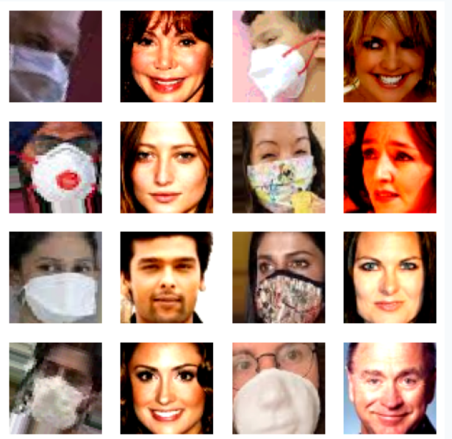

Figure 1.1. Samples of a dataset

III.II Preprocessing

The process of preparing the dataset during the model training consisted of arranging multiple steps to standardise the input data, preserve the separation of domains and make the process of loading the data efficient. Because the original images in the Face Mask 12K dataset had different resolutions, i.e., they could have 60x60 pixels, 80x80 pixels, etc., the starting point was the resizing of all the images to a unified resolution of 64x64x3 pixels. This standardisation makes all samples fit the input shape of the CycleGAN architecture and removes the necessity of image resizing during training, which is time-consuming and adds unwanted interpolation artifacts.

The data were grouped into two categories that are independent and unpaired (masked face (WithMask) and unmasked face (WithoutMask)). The images within these directories were loaded without labels, since the target here is unpaired image-to-image translation not supervised classification.Once loaded, all images were converted into floating point format and normalised to the range [-1, 1]. This scaling was selected since the generator output neurons have a tanh activation function, most effectively applied when input values are in this range. Normalisation can also be used to maintain consistency in both contrast scaling and brightness that would induce instability in adversarial training due to differences in pixel intensity ranges.

In order to evaluate, the 80 percent training and 20 percent testing data was partitioned into each domain. The masked and unmasked splits were done separately to prevent the overlap between the training and the testing sets. Critically, the sections of the test data were not involved in the generation of images. It was only used to evaluate model performance like comparing training and testing loss between epochs or qualitatively inspecting output on new images. Instead, the training split itself was only given on learning the domain mappings between the masked and unmasked faces.
The training data in each domain was unbatched into individual samples and then shuffled to ensure that each mini-batch would consist of a diverse set of faces, lighting conditions and masks. A shuffle buffer of 1,024 images was chosen to ensure diversity inside the batches at the cost of manageable memory consumption. The samples were batched into groups of 128 images after shuffling, which was selected as an optimal combination of GPU memory requirements and the stability of training.

Both the masked and unmasked datasets were subsequently zipped to enable the CycleGAN to take one batch per domain at a time. These pairs were generated randomly and they do not represent the same person, they were just paired so that they would receive the same training in the adversarial model at the same time.

Steps in preprocessing:

- Load the image
- Resizing the image
- Normalization
- Shuffling
- Batching
- Prefetching

III.III Model Architecture

The current system uses a CycleGAN structure to unpaired image-to-image translation based on two separate domains:

Masked Faces - facial occluded images.

Unmasked Faces - full or complete faces without a mask.

The model has four principal elements:

Generator G - transforms masked faces to more realistic unmasked.

Generator F - synthesises masked versions of unmasked images, to be used in cycle consistency enforcement.

Discriminator D - distinguishes real unmasked images from those generated by Generator G..

Discriminator J – discriminates between authentic masked images and images produced by Generator F.

This two-side training enables the model to learn both directions of the mapping without using paired samples, which is an important attribute in mask removal applications when samples with masked and unmasked image of the same person are infrequently paired or unavailable.

Generator Architecture
These two generators have a U-Net-style encoder-decoder architecture (Ronneberger et al., 2015) with skip connections. The encoder gradually down-samples the input to take into account high-level semantic data, whereas the decoder up-samples such data to recreate the target domain image.

Key characteristics:

Downsampling layers: It should be noted that we want to halve spatial resolution at each downsampling step, but we want to have more feature maps (32, 64, 128, 256, 512). Then stride notation can be used on convolutional layers (kernel size 4, stride 2) to downsample spatial resolution by 2.

Instance Normalization: Implemented following every convolution (except the initial layer) to regularise the training and learn to express styles apparently.

LeakyReLU Activation (0.2): The Leaky ReLU function is responsible for not loosing the non-zero gradients and thus minimizing the chances of dead neurons during training.

Skip Connections: This involves direct links between encoder and decoder levels at the same resolution level, so as not to lose fine details and geometry of the face.

Upsampling layers: The decoder has upsampling layers, where Conv2DTranspose with stride 2 can increase spatial resolution step by step. In each stage the upsampled feature maps are joined to the feature maps of the appropriate encoder to re-introduce the structural details that are being discarded in the downsampling procedure. The last output layer has the tanh activation, and it will output the pixels values in [−1,1][-1, 1][−1,1] range like the preprocessed inputs.

The U-Net design decision is informed by the fact that it has performed well on image translation tasks that require high structural fidelity. During mask removal, the eye and jaw areas are stable as other occluded areas like the mouth, nose, and chin are reconstructed.

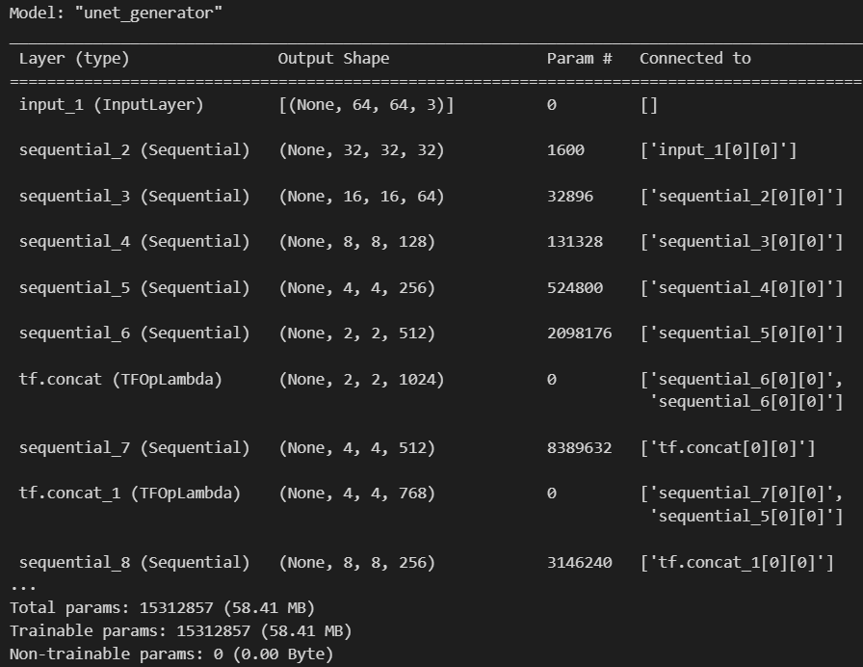

Figure 1.2. Description of Unet_generator

Discriminator Architecture
The discriminators are based on the architecture PatchGAN provided by Isola et al. (2017). A PatchGAN produces grid of decisions, rather than a single real/fake decision on an entire image.

Key characteristics:

Convolutional Layers: Stacking sequentially downsampling.Globalization to have larger progressive receptive fields (kernel size 4, 2-step).
Instance Normalization: Enhances stability of training and it is the most important step to get desired results.
Output Layer: Final: This layer gives a 2D map of authenticity scores with entries corresponding to the realism of local patch.
This local evaluation localizes high-frequency detail perseverance, making certain that the textures of the skin shading, the lip line and the hair fibers are genuine. This becomes especially significant when mask removal is involved, so that the lower-face area reconstructed by this method has to merge smoothly with the remaining unmasked areas of the image

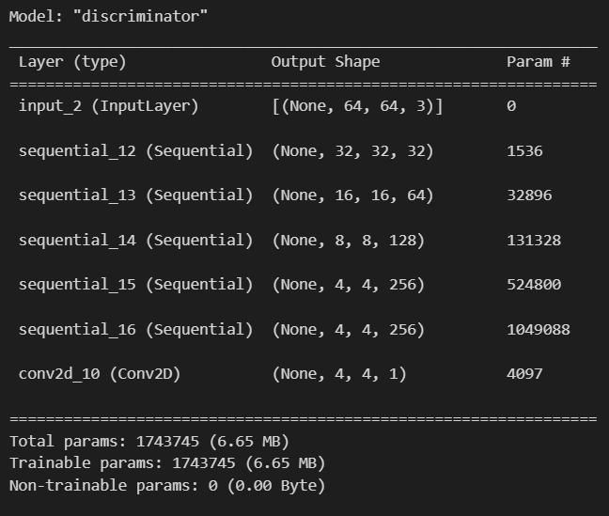

Figure1.3. Description of the Discriminator

III.IV Reason for chosing U-Net generators and PatchGAN discriminator

The choice of U-Net generators and PatchGAN discriminator:

- We use the U-Net generators with skip connections and PatchGAN discriminators based on the following considerations.

- Identity Preservation: Skip connections enable structural information to be kept at a minimum in terms of distortion eye nicks and the jawline.

- Texture Realism: PatchGAN emphasizes on local patches which pressures the generator to synthesize convincing fine-grained details on grounds.

- Training Stability: Instance normalization, LeakyReLU activations, and precisely initialized weights reduce the instability GANs are known to experience when learning.

- Domain Flexibility: The architecture is flexible to unpaired data which makes it applicable in real-life mask removal in which paired samples are not present.

III.V Implementation of CycleGAN Model And The Process Of Generating Images

The model is charged with the challenge of learning these pair-wise mappings between these spaces so that a masked image can be projected into a plausible unmasked representation and vice versa.

Structure and Components of a Model

Implemented CycleGAN has two generators and two discriminators. Where generator G will translate masked faces to unmasked faces, the reverse translation is done by Generator F. Whereas the discriminator D determines whether an image is in the unmasked domain or a fake generated one, the discriminator J does the same thing but concerning the masked domain. The dual-discriminator structure has the benefit that every generator is trained against a domain critic, which is essential to learn to generate domain-specific visual features.

In order to track the learning progress over time in the course of training, the model continuously tracks four critical metrics:

Discriminator loss (masked) - measures the accuracy of discriminator J with distinguishing between real masked and generated images.

Discriminator loss (unmasked) - examines discriminator D ability to recognize fakes in the unmasked domain.

Generator loss (masked) - estimate of the quality with which Generator F can produce masked images using unmasked inputs.

Generator loss (unmasked) - measures the capability of Generator G to model unrealistic unmasked faces based on their masked images.

CycleGAN training is dependent on the well-designed loss functions. There are three different things that the model learns in this implementation:

Discriminator Loss
The discriminator loss is carried out with the Binary Cross-Entropy (BCE) formulation. Real images are marked as ones and generated by zeros. Loss is calculated on both the actual and false predictions and the final discriminator loss is the average of these losses.
With respect to mask removal, this loss is critical as by having a good discriminator, they deliver a better learning signal to the generator. When the discriminator readily identifies the fake unmasked face, here there is pressure on the generator to improve its reconstructions, so the result has a more realistic skin texture, smooth merging of boundaries at the areas where the mask was removed, and retention of small details in the face.

Generator Loss
The generator loss will take BCE but mark the generated pictures with ones. This makes the generator work towards generating outputs that cannot be distinguished between the target domain real samples. In the case of Generator G, this amounts to generating unmasked face areas that inherently match the visible upper half of the face in terms of colour, illumination and shape. In the absence of such adversarial pressure, the generator might come up with results that are overly smooth or artificial and lack the fine resolution of real images.

Cycle Consistency Loss
Cycle consistency loss is important to the preservation of identity. It applies the law that a picture sent to the second domain and returned of them must be as similar as possible to the original. Considering the example, when a masked image is translated back to unmasked format, and again masked, the output must be similar in terms of visual and structural appearance to the original masked image. Such a limitation does not allow the generator to implement unnecessary changes to the identity and spatial continuity of the subject as they remain unchanged.

III.VI Model Compilation and Hyperparameter Selection

To enable fine control of learning rates and the momentum parameters, each generator and discriminator is allocated its own Adam optimiser. A learning rate of 0.0001 and beta1=0.5 has been selected empirically based on GAN research literature, and works well in trade-off between convergence speed and stability of the training. Independent optimisers can be used to avoid the problem of one network dominating its counterpart, a frequent failure mode in adversarial training.
This relatively large cycle-loss weight will allow the generators to be restricted even as discriminators press them towards more photorealistic textures. It is especially the case in the mask removal task, where structural integrity of the face of the person is important as much as visual reasonability.

III.VII Training Process and the Adversarial Dynamics

Each batch of data is trained in a two-stage feedback loop:

Discriminator Update: Discriminator D and Discriminator J are both trained with real and generated samples to enhance their potential in discrimination of fakes and authentic images.

Generator Update : Two Generators G and F are updated to tricks their respective discriminators and fulfill the cycle-consistency condition.

This unidirectional updating algorithm provides a balanced adversarial relationship. As time goes on, discriminators learn to detect the inconsistencies better, whereas generators develop their reconstructions in a way that would prevent detection, leading to a more natural-sounding mask removal.

Facial Tracking using Callback
A user-defined function Unmask is used to observe qualitative progress though out training. Employing a fixed number of masked views that are invisible at the end of each epoch, Generator G is used to reconstruct the associated unmasked faces. These are presented in grid rather than side-by-side pairs with their original masked images in the separate directory. This lets one directly visualize the performance of the model over epochs.
The removal of the mask in early epochs is not processed completely and the blending of the skin does not look natural. Over the course of training, the reconstructions are characterized by better boundary management, correct shading, and feet and face hair features, chin formats and lips. At the last phases, the model gives results that are visually compelling and identity fidelity is high.

CHAPTER IV. EVALUATION
This section discusses the evaluation of the CycleGAN model to remove the face mask. Two areas of interest that were targeted are adversarial training dynamics in terms of discriminator accuracy and structural reconstruction quality in terms of Structural Similarity Index (SSIM). This test was not concerned with the fine tuning of the model or decision variable adjustment-it was performed merely to see just how well the model works. The accuracy of the discriminators indicates the location of the healthy balance in training, and SSIM represents how closely the generated faces resemble the original structure. The combination of them provides an easy representation of the performance of the model.

IV.I Data Split

This data included two unpaired domains:

Masked faces (M)

Unmasked faces (U)

All the domains were partitioned into 80 training and 20 testing. The generator and discriminator networks were trained on training data, and a test data held out to assess the ability to fairly estimate generalization. All images were down-sampled to 64 * 64 RGB, normalized to [-1, 1] and organized into batches of 128 sample images.

In order to facilitate effective training, shuffling, prefetching, and error handling options were enabled in the TensorFlow data pipeline so that any corrupted sample would be ignored. This guaranteed that the model was trained with a variety and randomized batch sizes without unreasonable slugs. Also, it was strictly ensured that masked and unmasked test sets did not leak into training data. Preprocessing and batching were standardized, and thus the dataset was comparable between experiments, which enhanced the reliability and reproducibility of evaluation results.

IV.II Train Monitoring

The following metrics were followed throughout training per epoch:

Losses of two translation directions (Masked- Unmasked and Unmasked- Masked).

Discriminator losses by domain.

Discriminator accuracy: The percentage of the correct real vs fake classification by the discriminators.

Further custom logging callback was added to capture these metrics on both training and test data, and yet another callback was periodically printing out sample outputs (Masked and Unmasked reconstructions) to be viewed separately. This gave quantitative and qualitative feedback during the training process.

Moreover, loss curves were plotted along with time ranges to see any convergence, and the presence of defects, like mode collapse or discriminator overpowering. This was taken into account by monitoring the discriminator accuracy, to assess any changes in adversarial balance, over epochs. Visual samples also served as a preliminary warning system, pointing out issues such as absurd textures, blurred areas or a lack of preserving identity. In combination, these tools provided confidence that training progress could be tracked without bias and modifications, like the learning rates or regularization, could be made on the basis of clear signals rather than trial and error.

IV.III Discriminator Accuracy

Discriminator accuracy indicates the rate at which the discriminators identify the real images as opposed to generated images. Although it does not directly report the quality of the images, it conveys valuable diagnostic data on adversarial balances:

Weak generators may be indicated by very high accuracy (>90%).
Near Chance (about 50%) accuracy may indicate realistic images being generated.
Abrupt declines or unsteadiness is an indication of training breakdown.

Due to this, we report discriminator accuracy as a supportive metric, mostly to examine the stability of training. Such stable adversarial dynamics are necessary when dealing with face mask removal because the generator is always challenged to do better. When the discriminator is too powerful, the generator can not learn useful mappings between masked and unmasked domains. On the other hand, in case the discriminator is too weak, the generator will be able to take advantage of it and create unrealistic outputs that nevertheless will be able to trick the model. The monitoring of accuracy throughout epochs thus assists to explain variations in generator loss and to make a connection between them with visual quality of outputs. However, when paired with structural and perceptual metrics, discriminator accuracy itself is a helpful indicator of approximate realism and represents an upgraded view of the health of training.

IV.IV Structural Similarity Index (SSIM)

The Structural Similarity Index (SSIM) was also used as the main metric of evaluation in this work since it directly evaluates the perceptual fidelity of reconstructed images of the cycle-consistency constraint. SSIM also considers the luminance, the contrast as well as the structure pattern, which is unlike beam-based measures that only analyze raw intensity differences and thus it matches more with human vision. This is especially important to the task of face mask removal in which good perception of the fine structural details is needed like contours, distance between eyes, and symmetry of the face, to maintain identity.

Evaluation Design:

The measure was used to both cycle paths of the CycleGAN architecture:

M (Masked) U (Unmasked) M (Masked)

U ->M ->U (Unmasked -> Masked -> Unmasked)

Estimating the two directions allows SSIM to measure how reliably structure is maintained when images are translated across the domains and returned to their original form. These two measures guarantee that the evaluation of the model will not be based on the one domain and will give a better understanding of the rebuilding capacity of the model.

Implimentation Details:

TensorFlow was used to perform the evaluation using the inbuilt function, tf.image.ssim. Because SSIM requires inputs in the [0, 1] range, the normalized training range of [1, -1] was converted back to range [0, 1] by the helper function _to01. To avoid invalid results results were clamped in this range. A batch-wise SSIM, finally, was implemented on each set of reconstructions through the method ssim_batch_tf that averages the similarity scores on all the images represented within the batch.

To simplify testing, generator inference was run with training=False using the forward once routine, which makes sure that no stochastic layers (e.g. dropout or batch normalization updates) modify the results which can happen during testing. The compute_cycle_ssim function coordinates the entire evaluation cycle:

In masked domain (M), to reconstruct the original input each batch of the masked input G_AB (masked->unmasked) and G_BA (unmasked->masked). An SSIM measure is calculated between the original and the reconstructed masked images.

In the case of the unmasked domain (U) the same operation is operated backward.

The scores on all the test batches (or a subset of batches in the case that a maximum of batches is specified, which we took as 20 batches in our experiments to reduce run time), are combined.

The report lastly contains three values:

cycle_ssim_masked: average SSIM M-->U-->M.

cycle_ssim_unmasked: average SSIM U-->M--> U.

cycle_ssim_overall: average of the two.

The results are outputs as JSON object, and the number of computed batches per domain is also captured, and its traceability and reproduction are assured.

Scores Interpretation
SSIM values lie in the range of 0 to 1, with higher values approaching 1 signifying better structural fidelity. In practice:

SSIM < 0.3 is low quality reconstruction of visible distortion.

SSIM values in the range of 0.3–0.6 are deemed moderate and are commonly accompanied by visible artefacts.

Values of SSIM in the range 0.6–0.8 indicate sub-optimal structural preservation, yet they are generally acceptable in research contexts.

SSIM values greater than 0.8 correspond to resolutions of high quality that preserve fine structural detail and faithfully mirror the original input.

Scores above 0.6 keep the process successful, since they show that the generator has learned to restore the missing regions while maintaining overall facial identity. Yet SSIM on its own does not encompass every perceptual artefact, and slight blurring or uneven texture disturbances can still be noticeable. As a result, each set of SSIM scores was paired with a visual assessment of the resulting images.

The significance of the analysis.

The framework documents both domain-specific and aggregate SSIM values, thus it enables us to examine asymmetries in model performance. To give an example, a high SSIM in the unmasked domain paired with a low SSIM in the masked domain would indicate that the generator finds reconstructing faces that are occluded by masks more challenging. On the other hand, balanced outcomes across both domains offer a more robust source of evidence that learning is generalizable.

In this way, SSIM plays a dual function, It is used as a quantitative metric for comparing different training runs and hyperparameter settings and as a method to identify regions in which model accuracy excels, and those requiring further tuning.

IV.V Ethical Use of Facial Data in Mask Removal

Collecting and deploying facial data to train AI systems give rise to significant ethical implications, all of which were thoroughly reviewed and thoughtfully incorporated into this project

Despite the dataset having been publicly released, specific safeguards were put in place to reduce privacy risks:

- Every image was taken from anonymized, publicly accessible sources that contained no personal identifiers.

- No effort was undertaken to associate the dataset’s individuals with their identities.

- Within the project scope, any attempt to associate the generated reconstructions with real-world identity-verification systems is expressly forbidden.

- Every effort was made to regard the dataset as anonymized and strictly for research purposes, thereby lowering the associated privacy risks should the dataset be compromised or the model employed in unauthorized ways.

Informed Consent
Since the dataset was sourced from pre-collected, openly accessible repositories (e.g., Kaggle repository and CelebFaces), this study depended on the consent procedures enacted by the original dataset creators. Even so, fundamental ethical principles were consistently honoured.

- The model was developed exclusively for academic research and expressly not intended for commercial exploitation.

- This study did not involve recruiting any new human participants, thereby minimize consent-related risks.

- Researchers publicly recognized the ethical difficulties of reconstructing faces with occlusion to underscore appropriate usage.

- This approach guaranteed conformity with consent frameworks, all the while honoring the autonomy of the original dataset contributors.

Access Control and Transparency
- Knowledgeable safeguards were instituted to diminish the possibility of unauthorized or malicious exploitation of the dataset and trained model.

- The dataset was hosted on protected servers that offered restricted access, accessible solely to the project team.

- Through the use of authentication and detailed access logs, usage remained fully transparent.

- To forestall uncontrolled deployment in sensitive contexts, the trained model was not placed in publicly accessible repositories.

- By limiting access and upholding transparency, the project paired open scientific input with measures to prevent misuse.

CHAPTER V. RESULTS & DISCUSSIONS
By utilizing unpaired images of masked and unmasked faces, the CycleGAN was able to learn the mapping in the absence of paired supervision. The dataset was partitioned into an 80–20 train–test split, resulting in uniform representation of both domains and thereby diminishing bias in the evaluation process.

Figure X: masked dataset samples
Figure Y: Samples from the unmasked dataset
The partitioning enabled the model to transfer its learning to unseen test images and furnished a steady evaluation environment. Through the use of an unpaired configuration, the dataset mirrored real-world situations in which aligned masked and unmasked pairs are rarely obtainable. Such an arrangement rendered the task both more demanding and more representative, thereby underscoring the practical applicability of the method. The thoughtful partitioning of the dataset likewise curbed overfitting and enabled a consistent appraisal of its generative quality across disparate domains.

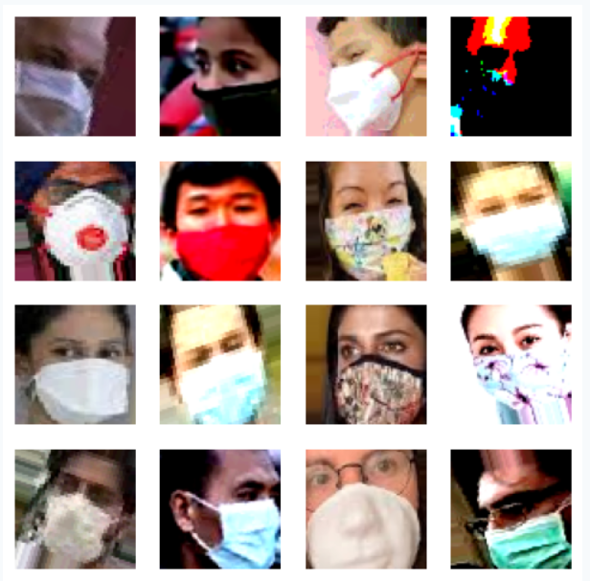

Figure 1.4. Masked Facial Images

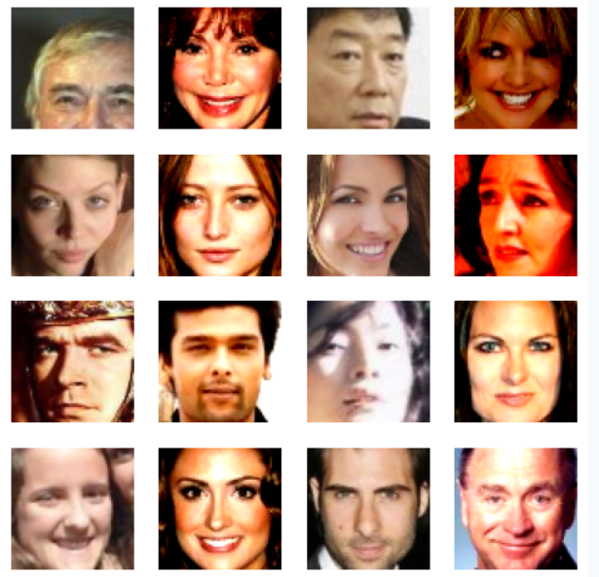

Figure 1.4. Un- Maksed Facial Images

V.I Generator Loss(Masked Domain)

The figure below shows the evolution of the generator loss over 100 training epochs in the masked-to-unmasked transformation. Early in training, the generator loss was comparatively high (13.8), reflecting its limited capacity to generate convincing unmasked facial reconstructions. However, the loss continued to lower gradually over the first 20 epochs down to below 7 indicating the generators quickly internalized basic mappings of masked versus unmasked facial structures.

Starting from epoch 20, the loss declined progressively and eventually settled into the 5–6 range, fluctuating only very slightly. These oscillations are a hallmark of adversarial training, mirroring the continual contest between the generator and the discriminator. The discriminator continues to advance at distinguishing synthetic images, and the generator concurrently adjusts to generate even more convincing reconstructions.

From epoch 80 onwards, the loss slows markedly, indicating that the generator has attained a stable equilibrium and will realize only marginal improvements in reconstruction quality. Such stability signals effective convergence in the adversarial process with only minimal mode collapse.

Taken as a whole, the progressive reduction and ultimate leveling off of generator loss indicate that CycleGAN has developed a stable mapping that permits reconstruction of unmasked facial features from their masked counterparts. Nevertheless, the converged loss values of roughly 5–6 indicate that, although the model effectively recovers global facial geometry, it still needs refinement to preserve finer identity-sensitive cues. These findings correspond to the qualitative assessment of the created images, which reveal a generally sound structural integrity but, from time to time, are marked by blurriness or artifacts.

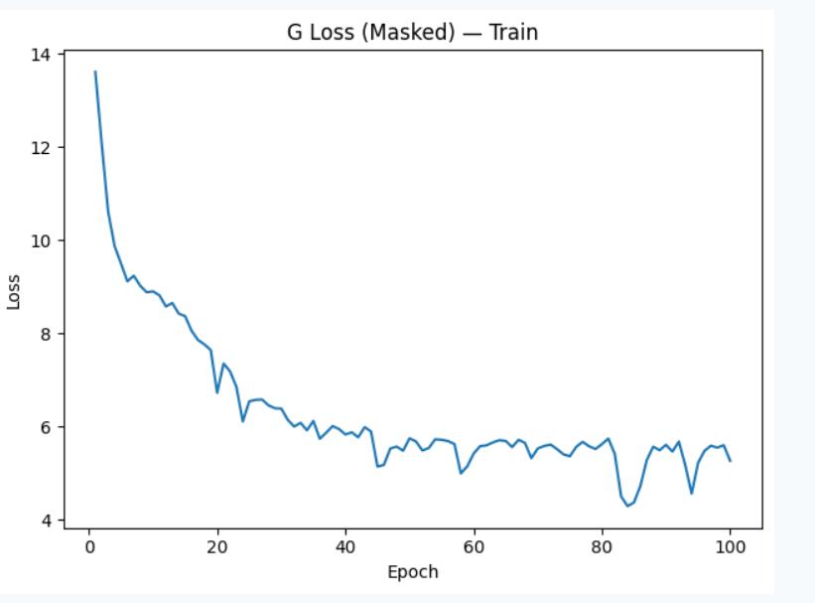

Figure 1.5. Graph for Generator Loss Masked (Train)

Figure X plots the generator loss for the masked-to-unmasked mapping on the test set. At the beginning the loss is quite high (about 12) that rapidly falls during the first 20 epochs, so the model is learning to deal with unseen events. Subsequently, the loss mostly fluctuates between roughly 5 and 7, rising and falling as a result of the adversarial training process. The results taken as a whole indicate that the generator behaves reliably on the test set, avoiding severe overfitting. Yet these recurrent oscillations indicate that the model finds it hard to craft stable, identity-preserving faces, underscoring the challenge of removing masks when training with unpaired data.

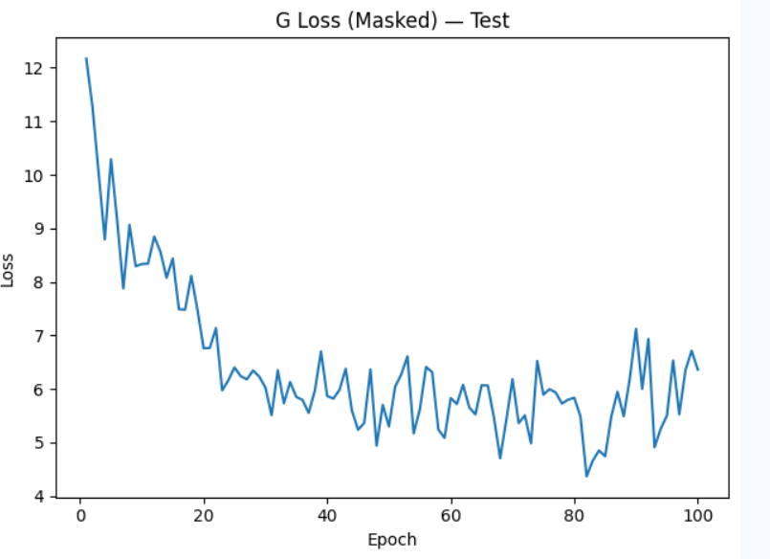

Figure 1.5. Graph for Generator Loss Masked (Test

V.II Generator Loss(Un-Masked Domain)

Figure X depicts the loss of the generator during the training stage for the unmasked-to-masked mapping. The initial loss is substantial (about 14), yet it falls off sharply over the first twenty epochs, indicating that the model is steadily mastering the transformation. Thereafter, the loss steadily diminishes and stabilizes in the 5–6 range, with only minor fluctuations. Such a steady trend indicates that the generator has found a stable mapping and is resistant to serious overfitting. These results show that the model can dependably produce masked outlines from unmasked inputs—a task that is comparatively simpler than removing a mask.

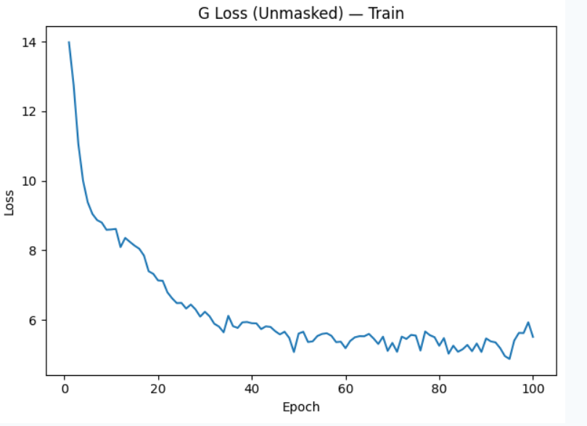

Figure 1.5. Graph for Generator Loss UnMasked (Train)

Figure X presents the generator loss observed on the test set for the unmasked-to-masked mapping. The loss falls steeply from about 12–13 to under 7 in the opening 20 epochs, indicating rapid learning. From there, the loss remains within the range of 5–7, subject to minor ups and downs that are usual in adversarial training.

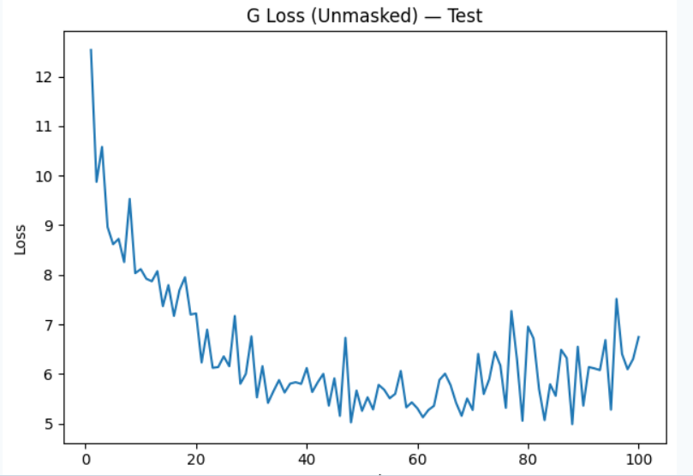

Figure 1.5. Graph for Generator Loss UnMasked (Test)

V.III Key Findings of the Generator Losses

Convergence is stable: Both masked To unmasked and unmasked To masked displays successful convergence without any severe overfitting.

Task asymmetry: Mask removal proves more challenging than mask generation, seen by the slight upward drift and decreased stability in the masked To unmasked results.

Generalization Ability: The model performs decently on new test samples, although adversarial dynamics still introduce some natural variability across the curves.

Performance quality: The steady decreasing curve in every generator loss confirms that the CycleGAN effectively and stably learned both transformation functions.

V.IV Discriminator Accuracy

Across 100 epochs, both the training and testing sets see the discriminator accuracy fluctuate between 0.55 and 0.90. Across the course of training, training accuracy settles within the 0.80–0.85 range, whereas testing accuracy usually hovers around 0.70–0.80. Such variability is to be expected, since adversarial training pairs two rival networks (the generator and the discriminator) that are continually adjusting to one another.

Early accuracy close to 0.9 implies that, early on, the discriminator had little difficulty distinguishing between real and synthetic samples, because the generator had still not learned meaningful mappings.

The variations across epochs signal the adversarial duel taking place between the two models. As the generator advances, the discriminator struggles to distinguish between real and generated samples, which consequently causes accuracy to decline. As the generator undergoes a brief downturn, the discriminator’s accuracy rebounds. Such a pattern of oscillation is commonly observed in GAN training.

Difference between train and test accuracy: Test accuracy is only marginally lower than training accuracy, indicating that the discriminator generalizes to unfamiliar data quite well. Yet a slight mismatch hints at a mild form of overfitting, as the discriminator is more convinced by training data than by the test samples.

Stable accuracy in the mid-range (0.7–0.85) is, in fact, a positive indicator during GAN training. In the case where discriminator is too strong generator could never improve, and discriminator too weak, adversarial learning signal would collapse. This observed oscillating mid-range performance suggests that both networks are learning simultaneously and remain in equilibrium.

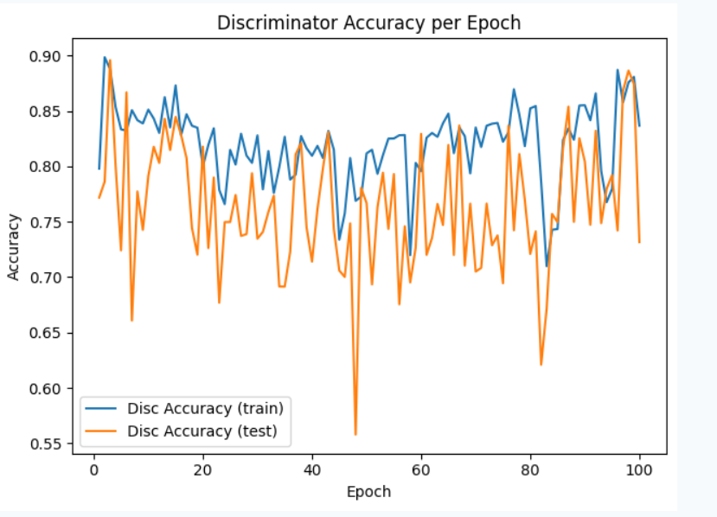

Figure 1.5. Graph for Discriminator Accuracy

V.V SSIM ACCURACY

The Structural Similarity Index Measure (SSIM) was used to assess the perceptual similarity between the reconstructed and original images. The CycleGAN recorded an average SSIM of 0.6536 when translating masked images into their unmasked counterparts and a SSIM of 0.7462 when reversing the process, for a mean SSIM of 0.6999 across both domains. These results suggest that the produced outputs maintained a moderate-to-high degree of structural similarity to their respective inputs.

Importantly, the higher SSIM observed for the unmasked-to-masked direction implies that the model can more readily produce masked faces, probably because adding texture layers is a simpler process than ‘hallucinating’ lost facial details. Conversely, the comparatively lower SSIM score for mask-removal underscores the greater difficulty of recreating blocked features—such as the nose and the mouth—while conserving identity consistency.

On the whole, the SSIM measurements confirm that the model delivers structurally consistent outputs, averaging more than 70% similarity. Although imperfect, these findings are encouraging while using unpaired training data, indicating that CycleGAN can effectively generalize to previously unseen test samples. Potential enhancements could target refining fine-detail recovery and safeguarding identity, through a combination of perceptual or identity losses coupled with an SSIM-based evaluation process.

In addition, the results reveal that SSIM serves as a valuable supplement to adversarial and cycle-consistency losses, since it explicitly represents the visual quality judged by humans. The disparity between mask addition and mask-removal scores likewise underscores the unequal difficulty of the two tasks, thereby indicating where model refinement should focus. Relative to earlier GAN-based face reconstruction studies, the obtained SSIM values lie in a competitive range, thereby affirming the validity of the approach. From a practical standpoint, this degree of similarity is enough for tasks like dataset augmentation, identity-preserving analytics, or enhancing masked face recognition systems. However, for images that demand photorealistic precision, additional refinements are still required. In overall, the SSIM evaluation reinforces the conclusion that CycleGAN offers a robust framework for addressing real-world face occlusion challenges.

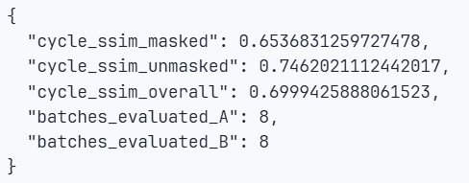

Figure 1.6. SSIM scores

V.VI Visual Performance

Qualitative evaluations of the CycleGAN model’s performance were carried out at intervals of 100, 500, and 1000 epochs. This illustrates the model’s strengths as well as the limitations it exhibits when used to learn bidirectional mappings between masked and unmasked facial images.

After 100 epochs, the generated samples exhibited only the opening phases of convergence. As the model began to grasp the broad spatial arrangement of facial features, the images stayed blurry and showed pronounced ghosting artifacts. Eyes and mouths were barely visible, though they exhibited no consistent placement or structure. At this point, the adversarial framework confirmed it was slowly capturing global facial distributions, though it had yet to sharpen identity preservation or attain finer levels of detail.
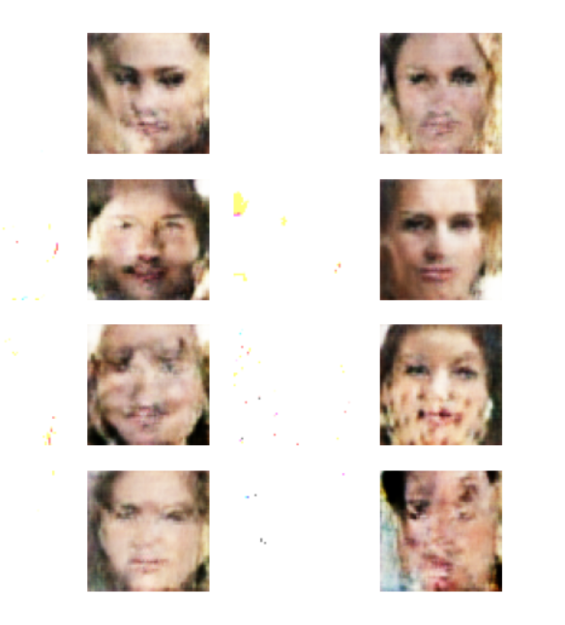

Figure 1.7. Image Generation after 100 epochs

At around the 500th epoch, a pronounced improvement could be seen. The generated faces displayed more stable structural coherence, accompanied by a sharper alignment of key features like the nose, lips, and eyes. As relative to previous stages, ghosting was diminished, and the skin tones displayed greater consistency across the sample set. Even so, a number of distortions still remained, especially in the symmetry of facial elements and the definition of minute details. This suggests that the model effectively reduced cycle-consistency loss, yet remained constrained in generating photorealistic textures.

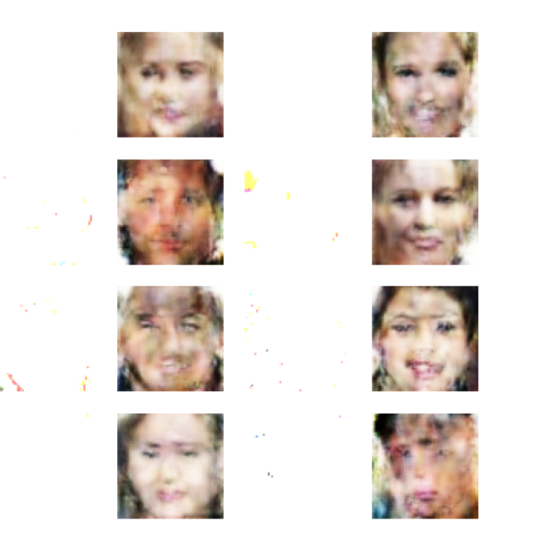
Figure 1.7. Image Generation after 500 epochs

When training reached 1000 epochs, the CycleGAN attained additional refinement, yielding images whose facial features were visibly sharper and more realistically depicting. In a number of instances, the results portrayed distinctly humanlike traits—boasting sharper detailing and reduced overlap of features as compared with earlier epochs. Yet, the limitations were still clear. Some generated images still exhibited blurriness, color bleeding, and an unnatural blending of facial regions. Such findings indicate that although extended training enhanced generative stability, the model had still not fully converged on high-fidelity results. In addition, extended training can raise the possibility of mode collapse or overfitting, helping to account for the occasional irregularities observed at this point.

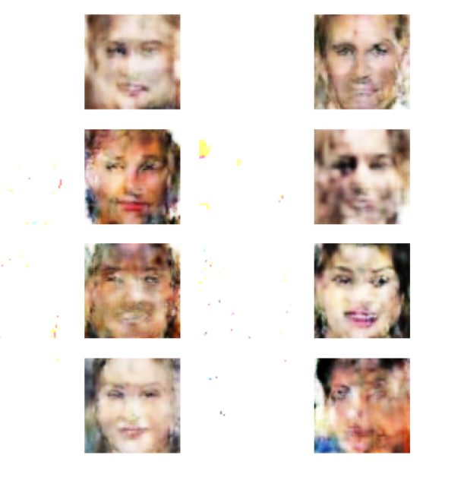
Figure 1.7. Image Generation after 1000 epochs

Collectively, these results underscore the model’s ability to train unpaired mappings between masked and unmasked face domains. The gradual improvement in qualitative metrics over the course of 100–1,000 training epochs underscores that adversarial training is highly effective at enhancing structural and textural realism. Nevertheless, the persistent blur and distortion highlight the underlying challenge of this task, particularly when dealt with unpaired data and in the absence of pixel-wise supervision.

The results suggest that, although our CycleGAN model successfully translates masks into unmasked images, further refinements are still required to achieve high-quality reconstructed images.

V.VII Limitations of the Model

The key limitations of the CycleGAN model are :

- Lack of Fine Details and Blurriness :

Even after extended training, the produced images retain a blurry appearance and miss out on high-frequency textures, like sharp edges, hair detail, and skin patterns. As a result, photorealism diminishes and the generated outputs are no longer well suited for tasks that demand precise accuracy.

2.Identity Preservation Problems

The model is unable to consistently preserve distinctive identity landmarks (e.g., facial symmetry, distinctive features). This limitation is particularly crucial for operations such as biometric recognition or face verification, where safeguarding identity is important.

3.Generalization Challenges

The model’s performance is critically influenced by the range of classes represented in the training dataset. Presented with unseen face types, shift in lighting conditions, or variations in masking, the outputs generally decline in quality, signifying insufficient generalization beyond the training distribution.

4.High Computational Costs with Unstable Results

The training of CycleGAN demands significant computational power and prolonged training runs. Even with 1000 epochs, the model has still not fully converged. In addition, adversarial training is fundamentally prone to instability, as it can suffer from mode collapse or rather violent oscillations.

5.Drawbacks of Unpaired Data

Given that CycleGAN operates on unpaired datasets, it cannot make use of exact pixel-level correspondences between the masked and unmasked images. As a result, the model struggles to produce precise facial details and commonly produces outputs that are ambiguous or unrealistic.

V.VIII Future Works

Although this study has illustrated CycleGAN’s potential for mask removal, a range of paths for future investigation still remains open. Attending to these concerns will boost technical performance and reinforce the responsible deployment of facial reconstruction technologies.

1.Improving Identity Preservation

Future work should give top priority to incorporating identity-preserving losses (e.g., perceptual loss or facial recognition embeddings) to protect distinctive features such as symmetry, jawline, and facial expressions. In this way, reconstructed outputs would maintain the individuality of their subjects rather than provide generic approximations.

2.Enhancing Fine-Detail Recovery

The current model currently exhibits difficulties with blurriness and a loss of texture. By integrating attention-driven CycleGANs, multi-scale discriminators, or progressive growing, the resulting reconstructions can be rendered more sharply and would more effectively preserve high-frequency features such as skin texture, lips, and hairlines.

3.Utilising larger and more heterogeneous datasets

GAN performance closely depends on dataset quality. Extending to broader, ethnically diverse, and condition-varied datasets (range of lighting conditions, mask variabilities, and facial pose angles) would strengthen generalization and robustness, particularly under real-world deployment conditions.

.4.Quantitative evaluation with benchmarking.

Going forward, future research should supplement SSIM with additional, more comprehensive metrics such as FID (Fréchet Inception Distance), LPIPS (Learned Perceptual Image Patch Similarity), and subjective evaluations by human subjects. Performing benchmarking on multiple datasets will facilitate more stringent comparisons and underscore instances of bias or failure.

CHAPTER V. CONCLUSION
The present thesis try to discover the advance face-reconstruction methodology by examining CycleGAN’s capacity for unmasking faces via unpaired image-to-image translation. The study analyzed the Face Mask 12K dataset, consisting of 5,000 masked and 5,000 unmasked facial images, and integrated each experiment within central research questions that assessed CycleGAN’s capacity to restore occluded areas, the structural accuracy of its generated images, and the ethical and practical consequences of these systems. The thorough protocols unveiled several useful observations about the strengths and constraints of leveraging unpaired adversarial learning to address the task of mask removal.

With respect to RQ1, the findings showed that CycleGAN can effectively learn to produce convincing unmasked faces from single-view masks without the use of paired supervision. The training trajectory exhibited steady trends of converging generator losses and waning discriminator accuracy, hence reaffirming the efficacy of adversarial learning. This indicates that unpaired GANs are indeed practical for real-world occlusion removal applications.

With regard to RQ2, a quantitative SSIM benchmark returned an average structural similarity score of 0.70, implying that reconstructed outputs achieved moderate-to-high fidelity in comparison with the original domain images. The larger gap in SSIM values between the mask-on and mask-off conditions highlights the inherently more complex process of inventing occluded facial details than of simply adding them. Qualitative evaluations conducted at 100, 500, and 1000 epochs revealed steady refinements, in which later stages yielded sharper, more coherent results even as they continued to be hampered by blurriness and identity preservation issues.

With regard to RQ3, the study further highlighted the attendant ethical considerations of automated face reconstruction. Although the technology’s feasibility was proven, its prospective misuse of privacy breaches and unauthorized biometric retrieval among them highlights issues that must be restrained through measures such as watermarking, controlled deployment, and rigorous fairness examination.

Alongside these specific findings, a number of broader themes also surface. First, the model’s dependence on unpaired datasets functions both as an advantage and a drawback. Although it allows the model to learn in the absence of paired samples, it limits pixel-level fidelity and can lead to identity preservation problems. Secondly, the persistent drift in adversarial stability continues to be a concern, as equilibrium in GAN training is based on a delicate balance. Third, variation in the training dataset limits model generalization, highlighting the need for a wider, more heterogeneous data set to secure robust performance in real-world scenarios.

This thesis introduced a CycleGAN-driven approach tailored to the Face Mask 12K dataset, thereby moving face mask removal research forward by:

(i) Establishing the feasibility of unpaired image-to-image translation for occlusion reconstruction.
(ii) Evaluating structural fidelity through SSIM pairing with adversarial metrics.
(iii) Recording the steady enhancement achieved over successive training epochs.
(iv) Situating the results within the ethical landscape of biometric data utilization.

In summary, this thesis conducted a systematic assessment of CycleGAN for mask removal with unpaired datasets, determined optimal configurations and constraints, and analyzed its prevailing generative capacity. The initiative deepened empirical and theoretical insights into GAN-based facial reconstruction—an active branch of computer vision that stands to underpin biometric authentication, healthcare, accessibility, and digital restoration. Insights should motivate continued efforts to build strong, transparent, and morally responsible generative models that can reconstruct human facial identity in heavily occluded settings.

References

Arjovsky, M., Chintala, S. and Bottou, L., 2017. Wasserstein GAN. Proceedings of the 34th International Conference on Machine Learning (ICML). Available at: https://arxiv.org/abs/1701.07875

Brundage, M., Avin, S., Clark, J., Toner, H., Eckersley, P., Garfinkel, B., Dafoe, A., Scharre, P., Zeitzoff, T., Filar, B. and others, 2018. The malicious use of artificial intelligence: Forecasting, prevention, and mitigation. arXiv preprint arXiv:1802.07228. Available at: https://arxiv.org/abs/1802.07228

Buolamwini, J. and Gebru, T., 2018. Gender shades: Intersectional accuracy disparities in commercial gender classification. Proceedings of the Conference on Fairness, Accountability, and Transparency (FAT), pp.77–91. Available at: https://proceedings.mlr.press/v81/buolamwini18a.html

Choi, Y., Choi, M., Kim, M., Ha, J.W., Kim, S. and Choo, J., 2018. StarGAN: Unified generative adversarial networks for multi-domain image-to-image translation. Proceedings of the IEEE Conference on Computer Vision and Pattern Recognition (CVPR), pp.8789–8797. Available at: https://doi.org/10.1109/CVPR.2018.00916

Goodfellow, I., Pouget-Abadie, J., Mirza, M., Xu, B., Warde-Farley, D., Ozair, S., Courville, A. and Bengio, Y., 2014. Generative adversarial nets. Advances in Neural Information Processing Systems (NeurIPS), 27. Available at: https://arxiv.org/abs/1406.2661

Gulrajani, I., Ahmed, F., Arjovsky, M., Dumoulin, V. and Courville, A.C., 2017. Improved training of Wasserstein GANs. Advances in Neural Information Processing Systems (NeurIPS), 30. Available at: https://arxiv.org/abs/1704.00028

Gupta, S., Pande, A. and Agarwal, M., 2021. Deep learning-based approaches for telemedicine and facial analysis. International Journal of Medical Informatics, 152, p.104476. Available at: https://doi.org/10.1016/j.ijmedinf.2021.104476

Harvey, A. and LaPlace, J., 2021. Ethical concerns in facial image reconstruction. AI and Ethics, 1(3), pp.189–199. Available at: https://doi.org/10.1007/s43681-020-00042-1

Isola, P., Zhu, J.Y., Zhou, T. and Efros, A.A., 2017. Image-to-image translation with conditional adversarial networks (Pix2Pix). Proceedings of the IEEE Conference on Computer Vision and Pattern Recognition (CVPR), pp.1125–1134. Available at: https://doi.org/10.1109/CVPR.2017.632

Jain, A.K., Ross, A. and Nandakumar, K., 2016. Introduction to biometrics. Springer. Available at: https://doi.org/10.1007/978-0-387-77326-1

Karras, T., Laine, S. and Aila, T., 2019. A style-based generator architecture for generative adversarial networks. Proceedings of the IEEE Conference on Computer Vision and Pattern Recognition (CVPR), pp.4401–4410. Available at: https://doi.org/10.1109/CVPR.2019.00453

Li, C. and Deng, W., 2019. Deep facial reconstruction for assistive communication systems. IEEE Transactions on Biometrics, Behavior, and Identity Science, 1(1), pp.72–83. Available at: https://doi.org/10.1109/TBIOM.2019.2896335

Li, X., Song, Y., Wu, S. and Zhang, C., 2018. Face completion with generative adversarial networks for forensics. Pattern Recognition Letters, 105, pp.11–17. Available at: https://doi.org/10.1016/j.patrec.2017.05.016

Radford, A., Metz, L. and Chintala, S., 2015. Unsupervised representation learning with deep convolutional generative adversarial networks. arXiv preprint arXiv:1511.06434. Available at: https://arxiv.org/abs/1511.06434

Raji, I.D., Smart, A., White, R.N., Mitchell, M., Gebru, T., Hutchinson, B., Smith-Loud, J., Theron, D. and Barnes, P., 2020. Closing the AI accountability gap: Defining an end-to-end framework for internal algorithmic auditing. Proceedings of the Conference on Fairness, Accountability, and Transparency (FAT), pp.33–44. Available at: https://doi.org/10.1145/3351095.3372873

Ronneberger, O., Fischer, P. and Brox, T., 2015. U-Net: Convolutional networks for biomedical image segmentation. Medical Image Computing and Computer-Assisted Intervention (MICCAI), pp.234–241. Available at: https://doi.org/10.1007/978-3-319-24574-4_28

Rossler, A., Cozzolino, D., Verdoliva, L., Riess, C., Thies, J. and Nießner, M., 2019. FaceForensics++: Learning to detect manipulated facial images. Proceedings of the IEEE International Conference on Computer Vision (ICCV), pp.1–11. Available at: https://doi.org/10.1109/ICCV.2019.00009

Schroff, F., Kalenichenko, D. and Philbin, J., 2015. FaceNet: A unified embedding for face recognition and clustering. Proceedings of the IEEE Conference on Computer Vision and Pattern Recognition (CVPR), pp.815–823. Available at: https://doi.org/10.1109/CVPR.2015.7298682

Thies, J., Zollhöfer, M., Stamminger, M., Theobalt, C. and Nießner, M., 2016. Face2Face: Real-time face capture and reenactment of RGB videos. Proceedings of the IEEE Conference on Computer Vision and Pattern Recognition (CVPR), pp.2387–2395. Available at: https://doi.org/10.1109/CVPR.2016.262

Tonge, A., Caragea, C. and Hsu, W., 2021. Ethical and consent considerations in facial data AI. AI & Society, 36(2), pp.345–356. Available at: https://doi.org/10.1007/s00146-020-00978-2

Wang, Z., Bovik, A.C., Sheikh, H.R. and Simoncelli, E.P., 2004. Image quality assessment: From error visibility to structural similarity. IEEE Transactions on Image Processing, 13(4), pp.600–612. Available at: https://doi.org/10.1109/TIP.2003.819861

Zhao, H., Gallo, O., Frosio, I. and Kautz, J., 2017. Loss functions for image restoration with neural networks. IEEE Transactions on Computational Imaging, 3(1), pp.47–57. Available at: https://doi.org/10.1109/TCI.2016.2644865

Zhao, Y., Wang, Q. and Li, Y., 2020. GAN-based facial reconstruction for rehabilitation. Journal of Visual Communication and Image Representation, 71, p.102813. Available at: https://doi.org/10.1016/j.jvcir.2019.102813

Zhu, J.Y., Park, T., Isola, P. and Efros, A.A., 2017. Unpaired image-to-image translation using CycleGAN. Proceedings of the IEEE International Conference on Computer Vision (ICCV), pp.2223–2232. Available at: https://doi.org/10.1109/ICCV.2017.244

